**Achilles International-Nashville**

**Friends Life Outreach Aug-Sept.-Oct. 2017**

**Training Guide**



***Welcome to Achilles International-Nashville. We are glad you are here!***

***Go Achilles and Go Friends Life!***

Please take a few minutes to read this guide, as it will give you an overview of Achilles Nashville and what to expect in our community outreach program with Friends Life.

**Meeting Place and Times**:

Achilles and Friends Life will meet at Sevier Park Community Center, conveniently located near Friends Life, at 3000 Granny White Pike, Nashville, TN, 37204.

Trainings will begin on Friday, August 4 and run through Friday, October 13, 2017.

All trainings will be from 1-2 p.m.

**Organization of training days:**

1:00 Meet in the Community Room at Sevier Park

1:05-1:10 Stretch

1:10-1:45 Walk/Run

1:50-2:00 Snack

**Communication**

Our primary communication mode outside of trainings is email; [achillesnashville@gmail.com](mailto:achillesnashville@gmail.com). Once you become a member, please check your spam settings so you can accept Achilles Nashville emails. You can also stay up-to-date with Achilles events and races through:

Website: achillesnashville.org

Twitter: @AchillesNash

Facebook: [www.facebook.com/AchillesInternationalNashville](http://www.facebook.com/AchillesInternationalNashville)

Facebook: Hope & Possibility <https://www.facebook.com/achillesnashvillehopeandpossibility/>

If you have any specific or individual questions, concerns, or comments related to Achilles/ Friends Life training program; please feel free to email those directly to Amy Harris, Assistant Director, Achilles Nashville at [amy.courtney.harris@gmail.com](mailto:amy.courtney.harris@gmail.com)

Our friends, families, staff, and volunteers at Friends Life will receive a weekly email from the coach with Achilles. This email will cover weekly training plan, any specific things to focus on during the week, and other walk/ run/ nutrition/ fitness information that is relevant for the week. Pictures from each training session can be found on the regular Achilles Facebook page.

**Achilles Mission**

*Our primary mission is to enable people with disabilities to participate in mainstream athletics in order to promote personal achievement, enhance self-esteem, and lower barriers to living a fulfilling life.*

An important component of our athletics program is reinforcing values relating to sportsmanship, competition, and fair play. It is expected that athletes, guides/volunteers, and spectators respect this mission by exhibiting appropriate behavior at Achilles/ Friends Life workouts and events. We support our athletes and Friends at whatever level they can participate and we encourage each and every person during training.

**About Achilles**

Achilles International is a large non-profit organization, that welcomes all people with disabilities who want to participate in mainstream athletics. Achilles International is best known for their running programs offered by local Achilles Chapters throughout the world, and their participation in races and marathons. There are over 65 chapters around the world. Achilles International-Nashville is our local chapter organization and the second largest in the world and the fastest growing chapter.

A Brief History of Achilles:

* In 1976, Dick Traum, an above-the-knee amputee, found himself approaching middle age and out of shape.
* After joining a local YMCA, Dick began running – small distances at first, eventually several miles.
* Within a year, Dick became the first amputee to run the New York City Marathon.
* The experience was life-changing, bringing a powerful sense of achievement and self-esteem.
* In 1983, seeking to provide that same opportunity to other people with disabilities, Dick created the Achilles Track Club, now called Achilles International.

In addition to our Leadership Team (Executive Director, Co-Assistant Directors) and our Board Members, our Nashville chapter is run by Achilles members and volunteers. All of these people generously give their time and energy to recruit participants, organize workouts, and secure funding. They work together to make our organization possible.

Regular running programs can be an important factor in improving health, energy, and self-esteem. In Achilles language, running means many things. It means conventional running, of course. But it also refers to walking, wheeling, or utilizing orthotic or prosthetic devices. In other words, it’s any form of locomotion that gets you through the route.

While our program focuses on running, in fact, running is simply the tool for accomplishing one of our main objectives, which is to bring hope, inspiration, and the joys of achievement to all. Achilles provides athletes with disabilities with a community of support. Within this community, runners gain measurable physical strength and build confidence through their sense of accomplishment, which often transfers to other parts of their lives. It’s not unusual for members and guides/volunteers to develop strong friendships; guides/volunteers are often surprised at how inspiring it is to watch an athlete with a disability become simply, an athlete. It is the sense of friendship, encouragement, and community that people find with Achilles. In training and racing together, athletes with and without disabilities learn to support each other and focus on what brings them together, their similarities, rather than what might keep them apart.

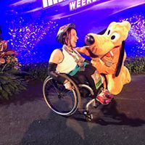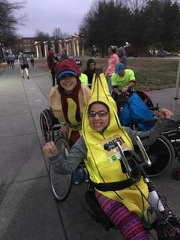

**Achilles Membership**

Achilles International – Nashville is comprised of athlete members and volunteer guides. People join Achilles for many reasons and with many goals: to improve physical strength, to build confidence, to have fun, or to help someone achieve their dream, and all of our members and volunteers work hard to achieve them.

Membership in Achilles International Nashville is ***free*** and includes coaching, workouts, chapter tee-shirts, and the Achilles International Achilles (NYC is headquarters) quarterly newsletter, “The Achilles Heel”. Once you have joined, you will also be placed on the Achilles Nashville email list to receive weekly notices about practices, events, and other relevant activities.

Friends Life participants will become Achilles members ☺

**General Run/Walk Information**

It is always important to drink plenty of water, eat healthy foods, and get plenty of good rest when you are training.

***Before You Run/ Walk:***

* Eat about 1.5-2 hours before the run. Some ideas are:
  + Oatmeal
  + Peanut butter on toast or a bagel
  + Carrots and hummus
  + Bananas (with peanut butter or plain)
  + Low-fat yogurt (with berries or without)
* Before each session, we will begin with stretches as a group (e.g., high knees, butt kicks, lateral lunges, forward lunges, arm circles, toe lifts)
* Start with a 5-10 minute warm-up of slow walking/running; be careful not to go out too fast

***After You Run/ Walk:***

* End each time with a 5-minute cool-down of slower walking/running
* Do some stretches (on your own; some examples are below)
* Drink water and/ or Gatorade! Achilles will provide this after practice each week.
* Eat something after you run/walk. Achilles will provide a light snack for after practice each week. Some food ideas are:
  + Banana or apple, with peanut butter
  + Cheese stick, pretzels
  + Popsicles
  + Watermelon

Good Stretches after running (hold each one for about 30 seconds)

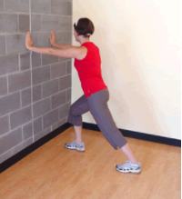

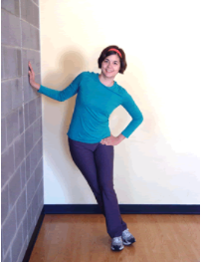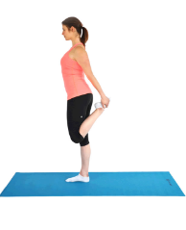

***What Should I Wear While Running/Walking?***

You will warm up as you exert energy by walking or running. Dress as if its 10-20 degrees warmer than it is! Achilles will provide 2 technical run/ walk shirts for all participants. These shirts are made of a dri-fit fabric and will wick away the moisture. Remember, cotton is rotten for running!

* Use the table below to help you decide what to wear:

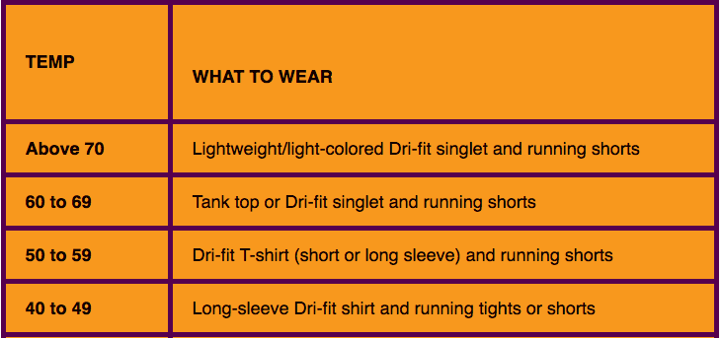

**Hope and Possibility Race October 21, 2017**

*Digital%20Skyline%20File.pdf*Friends Life is a beneficiary for the Achilles 4th Annual Hope and

Possibility Race. As such, $5 of every registration can be designated to go back to Friends Life organization. We hope all our friends, and their families, along with the staff and volunteers of Friends Life will participate in this 1-mile or 5-mile route that begins and ends off Harding Rd at the Dominican/ Overbrook Campus. It is our goal at Achilles to have our Friends geared up, motivated, and prepared. The registration link for this race is found at

<http://www.racesonline.com/events/achilles-nashville-hope-possibility-xae-5-miler-and-1-miler>

***What Should I do on Race Day (Hope & Possibility)?***

* Don’t eat/drink anything new- stick to what you know
* Make sure to get a good night of sleep the night before the race
* Drink water before and after the race
* If something hurts, it’s okay to slow down or walk
* Have fun and cheer on your friends and family

**Training and Plans:**

While Achilles will host a weekly practice for our friends at Friends Life on Fridays, we welcome you to come join us any Wednesday night at 6:30 p.m. at the McCabe’s Community Center, 101 46th Avenue North, Nashville, TN 37209, where we meet. We can pair athletes with guides for workouts any Wednesday night. We also offer a Saturday morning run/ walk option, locations vary…check the Web site and please RSVP to either Wednesday or Saturday runs (achillesnashville@gmail.com) so we can appropriately match athletes with guides for practices.

If you cannot make another practice, we strongly encourage you to find time at the Y, in your neighborhood, or at Friends Life to complete your other weekly workouts and be ready on race day!

Below is the Friends Life training plan to prepare you for the Hope and Possibility® 1-miler or the 5-miler. This plan can and will be modified as needed by individual participants to meet their current fitness levels and meet them where they are. This is a general guide.

**Training Friends Life**

**KEY Practice Days**   
*Run*: Run for the minutes indicated at a comfortable pace. (For walkers use brisk walk/slow jog for run)

*Walk*: Walk for the minutes indicated at a brisk pace (For walkers, use slightly slower walk for brisk pace)

**1-mile & 5-mile**

|  |  |  |  |  |  |  |  |
| --- | --- | --- | --- | --- | --- | --- | --- |
| **Week** | **Mon.**  **1 milers walk / 5 milers brisk walk** | **Tues.** | **Wed.**  **Easy to moderate effort** | **Thurs.** | **Fri.**  **Weekly Practice 1-2 p.m.** | **Sat.**  **Easy to moderate effort** | **Sun.** |
| **Week 1**  **Jul 31-Aug 6** | N/A | Rest | N/A | Rest | 1x around the course large group; 1x get pacing; 5-min cool down | Rest or 30- minute walk | Rest |
| **Week 2**  **Aug 7-13** | 10-15 min | Rest | 30-minute exercise | Rest | 10x (run 1 min + walk 2 min)* | Rest or 30-minute walk | Rest |
| **Week 3**  **Aug 14-20** | 15-20 min | Rest | 30-minute exercise | Rest | 10x (run 2 min + walk 1 min) | Rest or 30- minute walk | Rest |
| **Week 4**  **Aug 21-27** | 15-20 min | Rest | 30-minute exercise | Rest | 6x (run 4 min + walk 2 min) | Rest or 30- minute walk | Rest |
| **Week 5**  **Aug 28-Sept 3** | 20-30 min | Rest | 30-minute any exercise | Rest | 3 x (run 8 min + walk 3 min) | Rest or 30- minute walk | Rest |
| **Week 6**  **Sept 4-10** | 20-30 min | Rest | 30-minute any exercise | Rest | 3x (run 10 min + walk 1 min) | Rest or 30- minute walk | Rest |
| **Week 7**  **Sept 11-17** | 20-30 min | Rest | 30-minute any exercise | Rest | 2x (run 13 min + walk 2 min) | Rest or 30- minute walk | Rest |
| **Week 8**  **Sept 18-24** | 15-30 min | Rest | 30-minute any exercise | Rest | 2x (run 14 min + walk 1 min) | Rest or 30- minute walk | Rest |
| **Week 9**  **Sept 25-Oct 1** | 30 min | Rest | 30-minute any exercise | Rest | run 18 min + walk 2 min + run 10 min | Rest or 30- minute walk | Rest |
| **Week 10**  **Oct 2-8** | 30 min | Rest | 30-minute any exercise | Rest | run 20 min + walk 1 min + run 10 min | Rest or 30- min walk | Rest |
| **Week 11**  **Oct 9-15** | 30 min walk | Rest | 30-minute any exercise | Rest | Last Practice  Party Run 25 min + walk 1 min + run 5 min | Rest or 30- minute walk | Rest |
| **Week 12**  **Oct 16-22** | 30 min walk | Rest | 30-minute any exercise | Rest |  | ***Hope & Possibility***  ***1-miler or 5-miler*** | ***Rest. You earned it!*** |